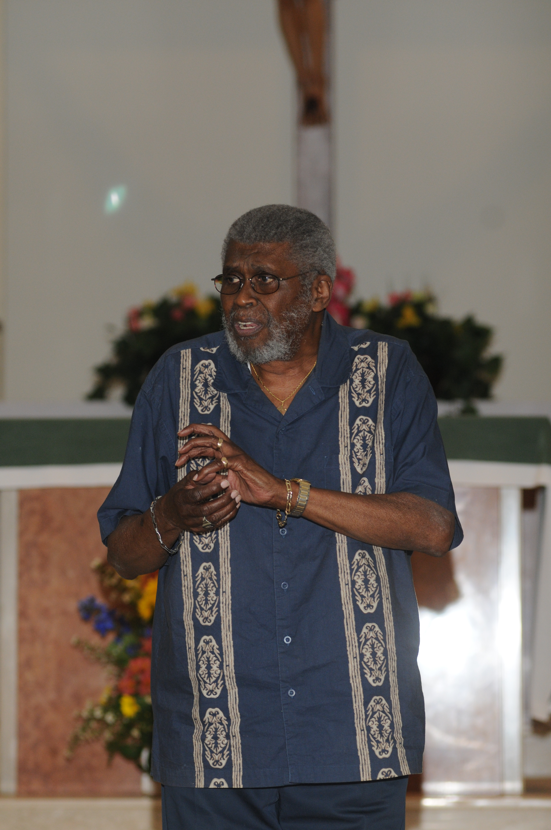
Eulogy, Bill Rogers, March 16, 2012
Rev. Gloria R. Carpeneto
I’d like to begin by thanking Dianne, and Jeff, and Tim & Angie & Bradley William (Bill’s grandson & namesake), and of course, Bill’s beloved Burt for bringing us all together today, and for welcoming us all to this hall that has become sacred space, where we can celebrate the amazing life and the incredible spirit of our friend, Bill Rogers.
Offering a eulogy for a storyteller like Bill Rogers is a daunting task. What can you possibly say in just a few minutes about a person whose life could be eulogized by anyone in this room, each of us with half a dozen great stories to tell, each one better than the next? Where do you start?
Well, I guess we can start at the beginning. We can start back in the 30’s somewhere, when Bill was a preacher’s son & a hairdresser’s boy. Growing up in a large African-American family in a house in Bristol, Tennessee, Bill grew into a deep love of a personal God, and an equally deep appreciation for whatever it was that made ladies happy. What a balance Bill always struck in his life between the gentleness of his mother who taught him to love beauty & the faith of his father, the preacher who taught Bill to believe that God’s eye is always on the sparrow … what a balance Bill always struck, actively working for justice & quietly holding peace in his heart … and in all of his life, what a balance Bill struck between great wisdom & equally great wit.
Bill lived through the Great Depression, and he lived about a third of his life before the passage of the Civil Rights Act of 1964. Matter of fact, one of the first stories Bill ever told me was about how he handled some of those times that were so bad in our country for people of color. When I think of this story, it captures Bill’s spirit for me. So I’ll share it with you now. I only hope you can hear Bill’s big, booming voice and see that beautiful smile. And I warn you – I’m going to tell you this story exactly as Bill told it to me, so be prepared.
One day, a long time ago (as all good stories must begin), Bill was traveling somewhere and of course, he was sitting in the back of the bus. When the bus stopped for gas in some small southern town, all the passengers piled off to use the facilities and get a little something to eat in the gas station snack bar. Bill got off too, and he headed around the back of the station (of course …) to use the COLOREDS-ONLY bathroom.
When he walked back into the gas station to buy a little something for himself to eat & drink, the man at the cash register looked at Bill with some contempt and he spit out those vile words, “We don’t serve niggers in here.” Bill shot right back at him, “Well, that’s OK, ‘cause I don’t eat ‘em either.” And in about half the blink of an eye, Bill was out the door, on that bus, and halfway down the road before that gas station attendant even knew what hit him.
Bill was never a malicious man. But he did not suffer fools lightly. And he never gave any human being – including himself -- any less respect than God, his Father, intended him to have. I think Dr. King would have been proud of Bill’s small act of humorous non-violent protest in that gas station that day.
In his military, government, and teaching careers … in his 36 years of marriage to Dianne, his precious Shorty … in his parenting of Jeff and Tim and yes, of Heather … in his love for Angie … in the pride he took in Bradley … and in all his later years as a beloved storyteller, Bill chose life, and he lived it abundantly. His interest was in quality; Bill did not want to die an unlived life.
In early 2012, at the age of 80, he made a choice for life that would impact him, and his family, and all of us forever. Bill chose to have surgery that he knew could go one way or the other. And he chose it with courage and calm and sound reasoning and no regrets – he wanted to live another full decade of life with all of us.
We know that in this past year, Bill never quite came back from that surgery. But even that didn’t keep him from life. Ask Dianne … ask his grandson Brad … ask Marianne and his hospice team … ask the friends who visited him regularly. He remained the same wonderful Bill. The only difference was that as he was slowly leaving us, we could see the Light of God shining through him a little bit more, every day, day by day. Bill was becoming more and more transparent with grace, and the Presence of God was strong in him.
A few days before he died, Bill’s family anointed him. They gathered around his bed, and one by one, they blessed him with holy oils as our final prayers were prayed. And in the calm and the peace and the solemnity of those moments, didn’t it say something about Bill that his best buddy – his Boston terrier, Burt -- jumped right up on the bed at the very end of all our prayers? Even Burt wanted to bless his friend, Bill, on his journey home to God.
There’s a traditional Hasidic story that I think Bill might have liked. observant Jews pray in Hebrew, and this story is about a poor, uneducated Jew who wanted to pray, but did not speak Hebrew. So not being able to pray as a faithful Jew, he simply began to recite the Hebrew alphabet over and over and over, until a rabbi asked what he was doing. The man told the rabbi, “The Holy One, Blessed is He, knows what is in my heart. So I give him the letters, and He can put the words together.”
Bill would have liked this man’s honesty. He would have liked his integrity. He would have liked the way he cut to the chase with God – I’m doing the very best I can down here. I give you the letters of the alphabet of my life. The rest I leave up to you. Such a simple, deep trust in the power & presence of God – that sure feels like Bill to me.
Thinking about Bill, I’m reminded of what a friend of mine once said I can’t think of a more wonderful thanksgiving for the life I have had than that everyone should be jolly at my funeral.
So today we come together to rejoice that God has raised Bill up on eagles’ wings.
We come together to celebrate that Bill is living in joy, with all the souls of those we have known and loved in all our lifetimes.
We come together to celebrate Bill’s life, to eat and drink and laugh and cry.
And because our lives have been so graced by the presence of Mr. Rogers, we come together today to be jolly.
And today, and every day in the lives that we now live without his presence among us, no one would wish that jolliness for us more than our dear brother Bill.

